UI UX

DOMAIN : Indian Fashion Apps

WEBSITES :


AJIO Savana

NAME: Shlok more, K V Satvik
PRN: 1032231797, 1032233686
PANEL: D

PROBLEM STATEMENT-
Critical Analysis of Interfaces: Analyse any one interface (website or mobile app) that you have interacted with that could be designed better. Focus on the interface design problems, rather than their engineering faults or business problems. Comment on its learnability, usability, consistency and metaphors.

CHATGPT VERSION
- AJIO
Learnability
Easy to understand, but homepage is cluttered with offers.
Usability
Excellent filters and search; too many pop-ups can distract.

Consistency
Consistent colours, icons, and layouts across pages
Use of metaphors
Uses familiar icons (cart, wish list, profile) effectively.
Navigation Structure

Well-organized categories but banner overload affects navigation.
Visual Hierarchy

Discounts and offers stand out, but homepage feels crowded.
Accessibility

Good font size and readability; some low-contrast banners.

Responsiveness

Works smoothly on both mobile and desktop.
Efficiency of Interaction

Quick checkout and useful shortcuts like wish list and saved addresses.
Feedback & System Status

Clear loading indicators, order confirmations, and notifications.
Error Prevention & Recovery

Gives helpful error messages and validation.
Aesthetic & Minimalist Design

Attractive but overloaded with promotions.
Content Readability

Detailed product information but sometimes text-heavy.

Search & Discoverability

Powerful search with many filters and recommendations.

Performance Perception

Generally fast; heavy banners may slow loading slightly.
Trust & Credibility

High trust due to Reliance brand and verified reviews.
Personalization

Highly personalized recommendations based on user activity.
User Satisfaction

High satisfaction due to variety and offers, despite clutter.

- SAVANA
Learnability
Clean interface, easy for beginners, but some features are hidden.
Usability
Simple and smooth shopping experience; limited filter options.
Consistency
Modern and consistent design with uniform styling.
Use of metaphors
Standard shopping icons, but some icons lack labels.
Navigation Structure
Simple navigation, though category organization can be limited.
Visual Hierarchy
Products are the main focus with clean spacing and layout.
Accessibility
Readable interface but limited accessibility features.
Responsiveness
Excellent on mobile; desktop version is less polished.
Efficiency of Interaction
Fast checkout but requires more scrolling due to fewer filters.
Feedback & support status
Good cart and wish list feedback, but loading indicators are basic.
Error Prevention & Recovery
Basic error messages with limited guidance.
Aesthetic & Minimalist Design
Clean, modern, and minimalist interface.

Content Readability
Simple descriptions but lacks detailed specifications.
Search & Discoverability
Search is good but offers fewer filtering options.
Performance Perception
Fast loading with smooth transitions.
Trust & Credibility
Professional look but lower brand recognition.
Personalization
Basic recommendations with limited personalization.
User satisfaction
High satisfaction for fashion lovers, but fewer features overall.

LEARNABILITY
How quickly a new user understands the interface.
Rating | Description
8.5/10 | - Home page displays highlights on offers a lot  - Very crowdy homepage  - Too much promotional content which distracts the user  - Options directly available without searching  - Pop ups of advertisements  - New user may require sometime
  9/10 | - Homepage focuses on products mainly rather than advertisements  - Clear and organised  - Large images helps to navigate easily  - Categories easily accessible
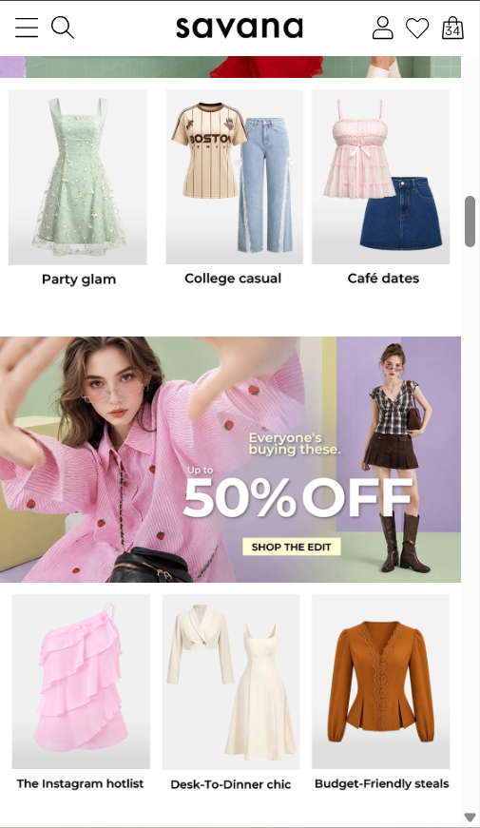
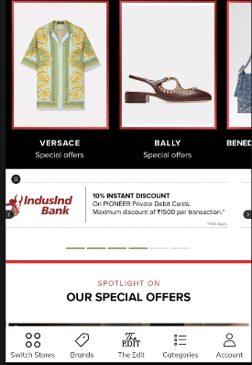

USABILITY
The ease with which users can complete shopping tasks efficiently.
Rating | Description
9/10 | - Advanced filters make product selection easier  - Wishlist, cart and checkout processes are easy to use  - Recently viewed items help user shop easily  - A lot of filter options are useful  - Frequently promotional pop ups can interrupt the browse
8.8/10 | - Product pages focus on visuals which makes use smooth and enjoyable  - Checkout is short and friendly  - Filter options are limited as compared to AJIO  - Sometimes finding a product needs extra scrolling
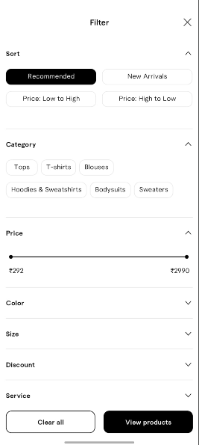
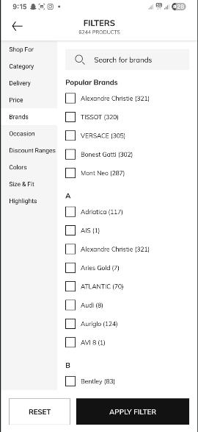
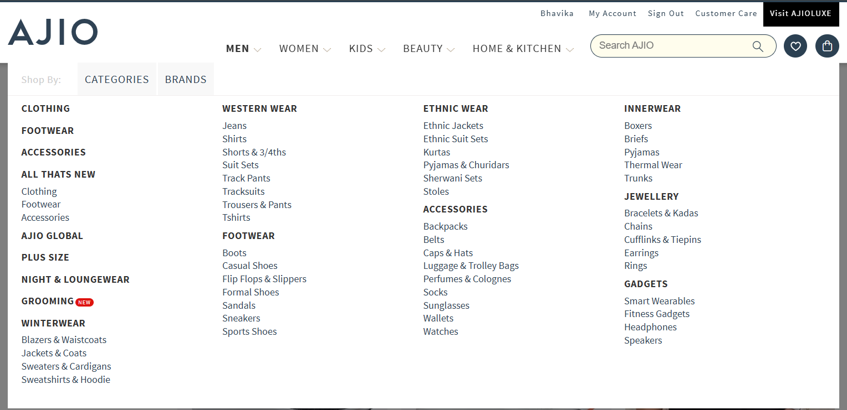

CONSISTENCY
Maintaining uniform colours, fonts ,icons, layouts and interactions
Ratings | Description
8.6/10 | - Consistent fonts, colours and icons are used throughout  - Uniform design pattern  - Promotional banners makes the page a bit busy  - Overall interface remains familiar while shopping
9.3/10 | - Uses a consistent colour palette and same font all across  - Uniform spacing and clean appearance throughout the app  - More minimal and feels modern plus visually balanced  - Visually same layout on desktop like on smartphone
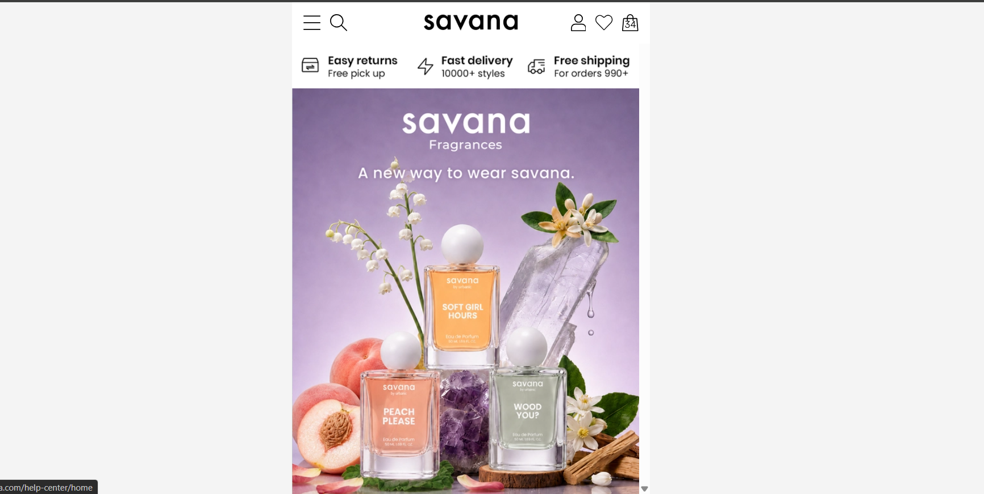
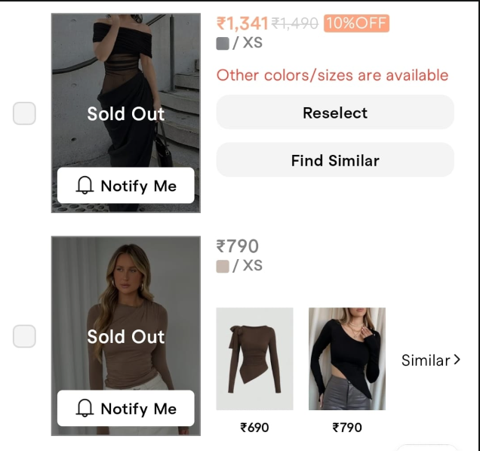

USE OF METAPHORS
Using familiar real-world icons and symbols to help users understand and navigate the interface easily
Ratings | Description
9/10 | - Uses familiar icons such as cart, wish list, search and profile  - Discount banners clearly indicated ongoing offers  - Shopping bag and search bar is easily accessible  - Basically everything is labelled properly and is easy to figure out
8.8/10  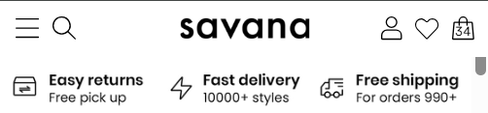 | - Uses standard shopping, wish list etc icons  - Product images act as visual cues for browsing through collections  - Some icons could include labels for better clarity  - Overall understandable metaphors and easy to use

Golden Rule | AJIO | Savana
1. Strive for Consistency | Most screens follow the same design, icons, and button styles. The homepage can sometimes look busy because of changing promotional banners. | The app has a clean and consistent design throughout. Colours, fonts, and layouts remain almost the same on every screen.
2. Seek Universal Usability | Easy for most users to shop, but first-time users may feel overwhelmed by the number of options and offers. | The simple layout makes it easier for new users to understand and navigate without much effort.
3. Offer Informative Feedback | Shows messages when items are added to the cart, payments are completed, or orders are placed successfully. | Gives clear confirmation when products are added to the cart or wish list and during checkout.
4. Design Dialogs to Yield Closure | After placing an order, users receive a confirmation page with order details, giving a clear sense that the task is complete. | Displays a confirmation message after checkout, making users feel confident that their order has been placed successfully.
5. Prevent Errors | Helps users avoid mistakes by validating coupon codes, addresses, and payment information before proceeding. | Basic validation is available during checkout, but the error messages could be more detailed and helpful.
6.Permit Easy Reversal of Actions | Users can remove items from the cart or wish list and cancel eligible orders without much difficulty. | Users can easily remove products from the cart or wish list, but cancellation options are slightly less flexible.
7. Keep Users in Control | Users have full control over shopping, filters, sorting, and account settings. Too many promotional pop-ups can sometimes interrupt the experience. | The interface gives users complete control with very few interruptions, making browsing feel smoother.
8. Reduce Short-Term Memory Load | Important options like Search, Cart, and Profile are always visible, but the crowded homepage may require users to process more information. | The clean interface and simple navigation reduce the amount of information users need to remember while shopping.

THANK YOU!!

